Japanese authorities request ShelterBoxes for the north
Fri 18/03/2011 21:31
Local government authorities in Japan’s Iwate Prefecture have requested 500 ShelterBoxes to provide emergency shelter and lifesaving supplies for families who lost their homes in last week’s tsunami.
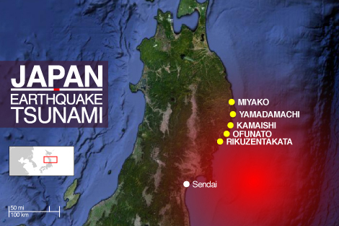
The request came via the local Rotary district and is initially for 100 ShelterBoxes for each of the following five cities: Miyako, Yamadamachi, Kamaishi, Rikuzentakata and Ofunato.

The ShelterBox Response Team (SRT) operating in the country are working in cooperation with the British Embassy, British military personnel and the US military to overcome the logistical challenges they are facing.
It is a seven-hour journey by road from Tokyo to the Iwate Prefecture and with fuel shortages, heavy snow, freezing temperatures and the ongoing nuclear situation there are a range of obstacles to overcome in order to ensure aid reaches the families who need it most.
‘Every disaster is different but this one is certainly posing a unique set of circumstances for us to deal with,’ said SRT member and ShelterBox International Director Lasse Petersen who has been in Japan since last Saturday.
‘We mobilised on day one because we knew there would be a need for the provision of emergency shelter. The specific needs request means we can now begin our distribution and we continue to be ready to respond in whatever capacity is required from us.’
The latest reports from Japan say the official death toll is now 6,405 with thousands more missing. More than 400,000 people are in temporary shelters including community centres and schools. Many of these have already become overcrowded and are not the long term solution to Japan’s emergency shelter needs.
‘In the Iwate Prefecture alone close to 50,000 people are in temporary shelter, more the 10,000 are isolated and 4,000 are missing,’ added ShelterBox Head of Operations John Leach.
‘We have close to 1,000 ShelterBoxes either in Japan or on their way and another 5,000 ready to move. The Japanese government is now focusing on getting assistance to the people sheltering in evacuation centres. The freezing temperatures, damaged infrastructure and severe lack of fuel are all concerns but we are confident of overcoming these barriers and getting aid to people who are in desperate need.’
The earthquake which struck Japan last week and triggered the subsequent tsunami was initially recorded as 8.9 in magnitude but was later upgraded to 9.0. An earthquake of this magnitude is, globally, a one in twenty year event. It caused a sudden vertical motion of the seafloor, displacing a huge mass of seawater which caused the tsunami to form. When the tsunami reached Japan’s coast, the waves were 10 to 15m high and travelling at speeds of around 500 km per hour.
Experts ShelterBox has spoken to say that, while it is impossible to predict earthquakes, they cannot rule out the possibility of another earthquake above 8.0 in magnitude striking off Japan’s east coast in the near future.

